IKM-Manning Middle School
6th, 7th, 8th Math Handbook
2015-2016

Name _____________________ Grade ___________

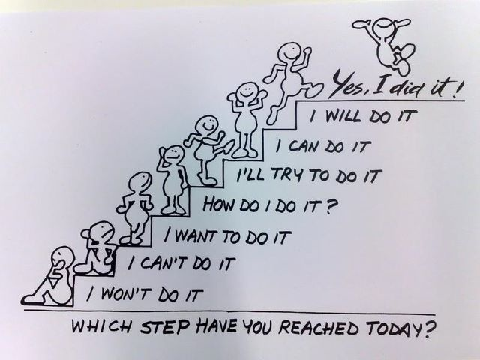

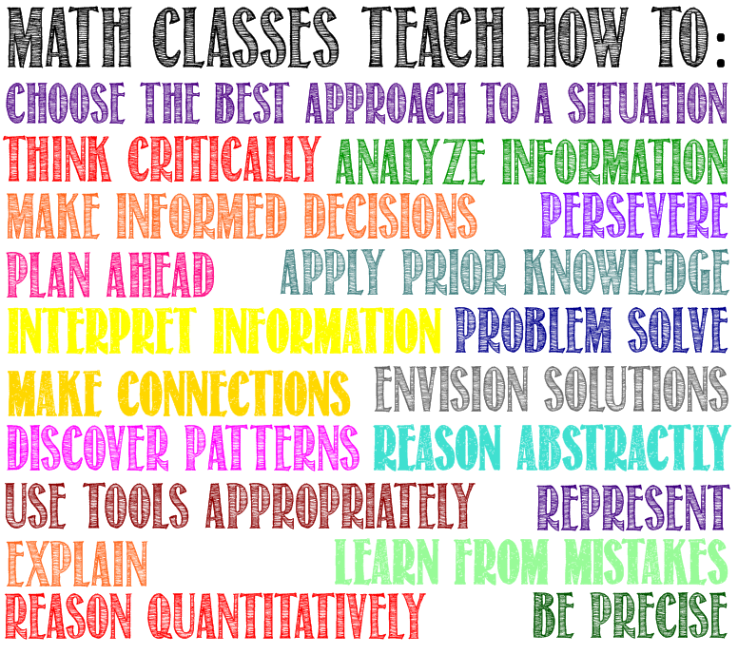
IKM-Manning Middle School
6th, 7th, 8th Math Handbook
2015-2016

Classroom Rules:

• Be Respectful • Be Responsible • Be Ready for Class

Required Materials:
- pencil • loose leaf paper
- textbook • 3-ring binder (black)
- pen (any color) • 2 composition notebooks (at least 100 pages in each)

Homework:
- Homework is due at the beginning of class, the day it is due.
- Homework must be organized and legible. Sloppy or unorganized work is unacceptable.
- Work done in ink will not be accepted and must be redone.
- A sufficient amount of work must be shown for each homework problem.

Homework Scoring:
Homework completed with all problems correct and a sufficient amount of work for each problem will be given 1 point. Homework which is not completed, has one or more incorrect answers, or is lacking a sufficient amount of work will be given 0 points until the assignment is completed, with all problems correct and a sufficient amount of work, at which time the assignment will receive 1 point.

*Students Who Earned 80% or Better on the Most Recent Test
Homework completed with a sufficient amount of work for each problem will be given 1 point. Homework which is not completed or is lacking a sufficient amount of work, will be given 0 points until the assignment is completed, with a sufficient amount of work, at which time the assignment will receive 1 point.

All homework assignments for a chapter must be completed by the date of the chapter test. Homework assignments which are not completed by that date will receive 0 points.

A Weekly Quiz will be given every Thursday. Corrections and/or retakes will not be given for homework Quizzes.

Tests:
- Any test can be retaken. An online Test Retake Ticket must be completed prior to retaking a test.
- Test retakes may be taken before school, after school, or during study hall and must be scheduled with Mrs. Wall at least one day in advance.

Test Grading:

The number correct will be calculated for each test and the following scores will be given:

Number Correct | Score
20 | 100 (A+)
18, 19 | 95 (A)
16, 17 | 90 (B)
14, 15 | 85 (B)
13 | 80 (C+)
12 | 75 (C)
11 | 70 (D)
10 | 65 (D)
9 | 60 (F)
8 | 55 (F)
7 | 50 (F)
6 | 45 (F)
5 | 40 (F)
4 | 35 (F)
3 | 30 (F)
2 | 25 (F)
1 | 20 (F)
0 | 0 (F)

Course Grading:

Grades will be calculated using weighted grading

Tests 60%

Homework 5%

Quizzes 25%

Notebook 10%

Grading Scale:
The IKM-Manning Middle School grading scale is outlined in the Student Handbook on pg. 11 as follows:
All classes that assign grades by percentages will use the following grade cutoffs:
A 94%
A- 92%
B+ 91%
B 84%
B- 82%
C+ 81%
C 74%
C- 72%
D+ 71%
D 64%
D- 62%
F < 62%

Mrs. Wall’s Schedule
Class | Period / Time
6th Grade Math | 1st / 8:55-9:01
6th Grade Math | 2nd / 9:04-9:48
8th Grade Math | 3rd / 9:51-10:35
8th Grade Math | 4th / 10:38-11:25
Lunch | 11:25-11:50
STAR | 11:50-12:15
7th Grade Math | 5th / 12:19-1:03
7th Grade Math | 6th / 1:07-1:51
Planning Time | 7th / 1:54-2:38
7th / 8th Grade Study Hall | 8th / 2:41-3:30

